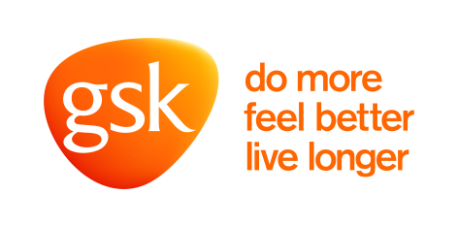

UK patient group funding

Body and Soul

During 2016:
- GSK provided an unrestricted core funding of £30,000 towards a range of awareness activities

Our support represented less than 2% of their overall income.

